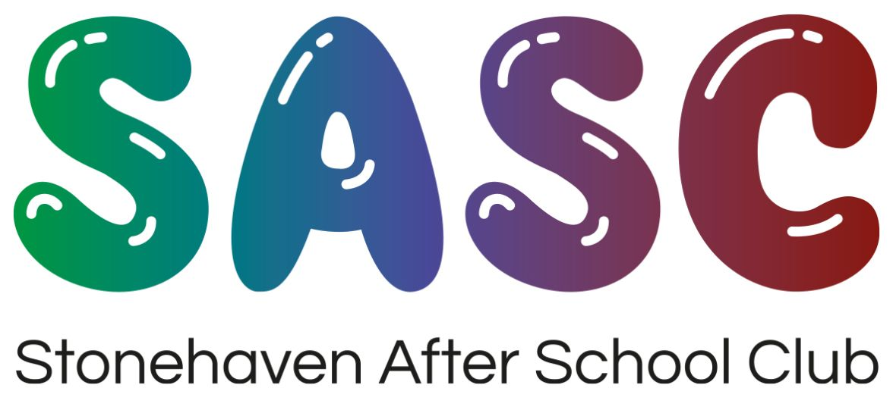
Easter Holiday Programme 2020
For more information please call 07710515640 or email admin@thesasc.co.uk

Week 1

Monday 6th – Stain glass Easter painting,
Easter egg designing, Bingo with prizes, Athletics,

Tuesday 7th - Decorating wooden Easter
decorations, Dodgeball, Cloud dough, Bookmark designing.

Wednesday 8th – Ceramic Easter figures
Easter foam friends, Badminton, Beach Clean,

Thursday 9th – Creating Easter glasses,
collage Easter pictures, Boxing, Leisure Centre Park, Sumo Suits

Friday 10th – Crathes Castle Easter Egg Hunt (Trip), Easter Bonnet making competition, Pin the tail on the Bunny

Week 2

Monday 13th – Baking Easter nests,
Hama Beads, Save the egg (promoting responsibility), Talent show,

Tuesday 14th – Easter mosaics, T-shirt
designing, Team building large scale construction, Football, Sumo Suits

Wednesday 15th – Aberdeen Science
Centre (Trip), Story writing competition, Marble Art, Darts, Aqua Beads

Thursday 16th – Sock puppets, Clay
modelling, Planting in our outdoor area, Just Dance competition,

Friday 17th – Play dough, friendship
bracelet making, Balloon Tennis, Air Hockey

Unlimited Fun

Additional to all fun and activities outlined in the Holiday programme we also have daily opportunities for outside play, play on the Nintendo Switch, physical activities, arts and crafts, dancing and much much more.

Additional Notes
- Spaces are allocated at a first come first served basis.
- Booking forms must be completed and returned by 30th March 2020, any forms returned after this date
- will be marked to
be charged at
£4.40 per hour
that your child/
children are in.

- New registrants to club must complete a registration pack and care plan for their child/children before attending club.
- A registration fee of £15 will be added to all new registrants invoices.
- Packed lunches must be provided with no hot foods, grapes must be cut up. Please be mindful of Allergens as we have children with allergies and also please do not include foods containing nuts.
- Morning and afternoon snacks will be supplied by SASC.
- K.I.C outings are for Primary 6s and 7s.
- Consent forms must be completed and returned before the day of any trip.
- Trip days will be capped due to spaces available on buses..
- No additional payments are required for trips, SASC cover this.
- We are open 7:30am – 6pm.

Fees Holiday and In-Service day fees are as follows…..
Child Day Week Half Day (5hrs)
1st £25.00 £125.00 £19.00
2nd £19.00 £95.00 £17.00
3rd £19.00 £95.00 £17.00

The above prices are for children booked in before 30th March 2020, any bookings after this will be charged at £4,40 per hour.
Additional bookings after this day will be accepted at the Managers discretion as staff to child ratio is important. Timely bookings will allow us to allocate a staff rota.
Cancellations – Once bookings have been made these will be charged at the full rate applicable.

General things to remember
- Children must be equipped with appropriate clothing for the time of year or nature of the activities.
- Packed lunches.
- Change of clothes if necessary.
- Medication if applicable, completed medication forms please allow time to complete these.

